Module 4
X File – Hunting for the origin of Atypical Pneumonia

A. Where has Atypical Pneumonia (SARS) spread to?
Table 1 shows the number of reported atypical pneumonia (SARS) cases in different areas of the world.

Country / City | Date
Country / City | 17/3/03* | 24/3/03* | 9/4/03# | 19/4/03#
Australia | - | - | - | 3
Belgium | - | - | - | -
Brazil | - | - | 1 | 2
Canada | 8 | -11 | 94 | 132
China | + | + | 1280 | 1512
China, Hong Kong SAR | 95 | 260 | 970 | 1358
China, Taiwan | - | 6 | 19 | 29
France | - | 1 | 4 | 5
Germany | 1 | 4 | 5 | 6
India | - | - | - | 1
Indonesia | - | - | - | 1
Italy | - | 2 | 3 | 3
Japan | - | - | - | 4
Kuwait | - | - | - | 1
Malaysia | - | - | 1 | 5
Mongolia | - | - | - | 3
Philippines | - | - | - | 1
Republic of Ireland | - | 1 | - | 1
Romania | - | - | 1 | 1
Singapore | 20 | 65 | 118 | 177
South Africa | - | - | - | 1
Spain | - | 1 | 1 | 1
Sweden | - | - | - | 3
Switzerland | 2 | 2 | 1 | 1
Thailand | 1 | 5 | 7 | 7
United Kingdom | - | 3 | 5 | 6
USA | - | 37@ | 149 | 220
Vietnam | 40 | 58 | 62 | 63
Others | - | - | - | -
Total | 167 | 456 | 2722 | 3547
Table 1 Source: http://www.who.int/csr/sarscountry/

Remarks:
- The number of cases changes over time. Cases will be counted if patients show certain symptoms. Previous reported cases will then be discarded if further investigation proves that the person is not infected by SARS.
- * As of 1 February 2003.
- # As of 1 November 2002.
- + The information on China is still being updated.
- @ inclusive of suspected cases.

- By browsing the website of the World Health Organization, find out the latest figures and fill in the last column of Table 1.
(http://www.who.int/csr/sarscountry/)

- According to the information on Q.1, locate the countries and city where SARS cases have been reported on the atlas below.

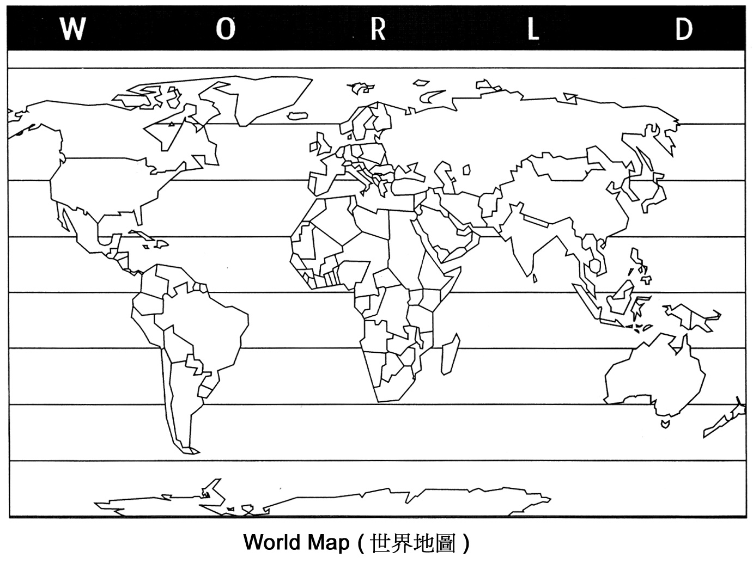

- Name six countries or city which have the greatest number of reported cases as shown on the last column of Table 1. Draw appropriate graph to show the changes in the number of cases for the period mentioned in Table 1.

- According to Table 1 and the graph you have drawn, describe the extent of the spread of this disease.

- How dispersed is the spread of reported SARS cases in the world?

B. Hunting for the origin of the disease

The following are extracts of some of the reports announced by the World Health Organization (WHO). Read carefully.

Disease outbreak reported – 12 March 2003

In Vietnam, the first SARS case was of unknown origin. He felt unwell during his journey from Shanghai and Hong Kong SAR, China and fell ill shortly after arrival in Hanoi. Following his admission to the hospital, approximately 20 hospital staff became sick with similar symptoms.

Disease outbreak reported – 16 March 2003

On 13 March 2003, the Ministry of Health in Singapore reported three cases of SARS in people who had recently returned to Singapore after traveling to Hong Kong Special Administrative Region of China…..

As of 15 March 2003, seven cases have been reported in Canada; two of whom have died. The cases have occurred in two separate extended family clusters. In both clusters at least one member of the family had traveled to Hong Kong Special Administrative Region of China within a week of developing symptoms.

Disease outbreak reported – 20 March 2003

WHO has welcomed a report from the Hong Kong Department of Health, released yesterday, that may have identified the “index” case in the outbreak in the Prince of Wales Hospital in Hong Kong. The investigation revealed that 7 people staying in or visiting the Metropole Hotel in Kowloon during 12 February and 2 March have infected SARS. The local Hong Kong resident who visited a friend staying in this hotel, is believed to be the index case. The visitor from the mainland, who became sick a week before staying at the hotel, is considered the original source of the infection.. Among the other 5 persons staying on the same floor, 3 of them are from Singapore and 2 from Canada.

Disease outbreak reported – 21 March 2003

WHO was first officially informed of the outbreak on 11 February, when the Chinese Ministry of Health reported that 305 cases of acute respiratory syndrome of unknown cause had occurred in six municipalities in Guangdong Province in southern China.

Disease outbreak reported – 8 April 2003
The SARS outbreak in Guangdong Province is presently the largest and oldest known outbreak of SARS. A 64-year old professor of Zhongshan University who lived in Guangzhou is thought to be the index case who sparked the outbreak in Hong Kong. During late February, he stayed in room 911 on the ninth floor of the Metropole Hotel. Guests staying on the hotel’s ninth floor sparked outbreaks in other countries when they returned to their homes in Toronto and Singapore. A 48-year-old American businessman, who also stayed on the 9th floor, is believed to have originated the outbreaks in Hanoi and in Hong Kong’s Princess Margaret Hotel, where he was transferred. One local Hong Kong resident, who visited a friend on the ninth floor, subsequently sparked an outbreak in a second Hong Kong hospital.

Source: http://www.who.int/csr/don/en/



- In groups of two, based on the information provided, trace the possible origin of the spread of SARS by completing the following flow diagram.
Vietnam
Singapore
Canada

- Why can SARS spread to such a long distance within a short period of time?

- Do you think the first case you’ve drawn in the diagram of Q.1 is really the origin of the disease? Why do you think so?



